

|  |
| --- |
|  |

Quadcopter and state of the art camera

# Executive summary

T

he current consumer electronics market is experiencing unprecedented change—and with that changes comes great opportunity. Together, Contoso’s camera division and it’s Adventure Works quadcopter division are ideally poised to take a market leadership position and deliver quality, consistency, and innovation to their customers.

Increasingly, photograph is chaning. People live their life with a camera in hand and sales of traditional cameria’s are in decline. At the same time technology enhancement have brought quadcopter technology to the masses, creating a new platform for digal photography. The industry challenge remains clear: Understand your customers, anticipate their future requirements, and deliver above their expectations.

That’s why a combination of our camera technology and quadcopter technology makes sense. No one in the consumer electronics market has a better understanding than Contoso of its long history of exciting innovation, turbulent disruption, and remarkable growth. And no one in the market consistently navigates through these changes and empowers its partners like Contoso.

# Why Contoso camera technology?

Of all the camera and quadcopter companies out there, what makes Contoso different? Four key points, discussed in more detail below, prove how our partnership would be unique and powerful:

* Customer-focused approach.
* Award winning camera technlogy.
* Aligned priorities and goals.
* Industry leading customer electronice experience.

## 

For more than three decades, Contoso has delivered positive sales results to its partner companies.

A close up of a logo

Description generated with very high confidence

**Figure 1**: Sales increases over projections, 2010-2014, for sample Contoso partners

Sales analyses from 1974-2013 show clear revenue growth from year to year, with compounding benefits as collaboration between companies increased. More recently, Northwind has realized increased sales of 15.6% over expected from 2010-2014, due to Contoso partnership (Figure 1). That’s the kind of value Contoso can bring to Adventure Works. Immediate, impactful growth across your consumer electronics divisions.

But it goes beyond sales—Contoso delivers innovative, high-quality products in a manner aligned with your business goals. In 2014 alone, we’re scheduled to launch several groundbreaking products in our television and home audio markets.

## What you get with Contoso camera technology

Partnering with Contoso provides a host of benefits, and there’s never been a better time to start. Contoso partner companies usually realize both increased revenue and sales by the third month, on average, and often sooner than that. From 2010-2014 alone, partners have realized up to 86% over projected market growth by integrating Contoso product lines (Figure 2). Moreover, analysts are projecting Contoso to capture up to 42% of the burgeoning 3D TV market in the next year.

**Figure 2**: Increasing revenue versus expected over time with partnership

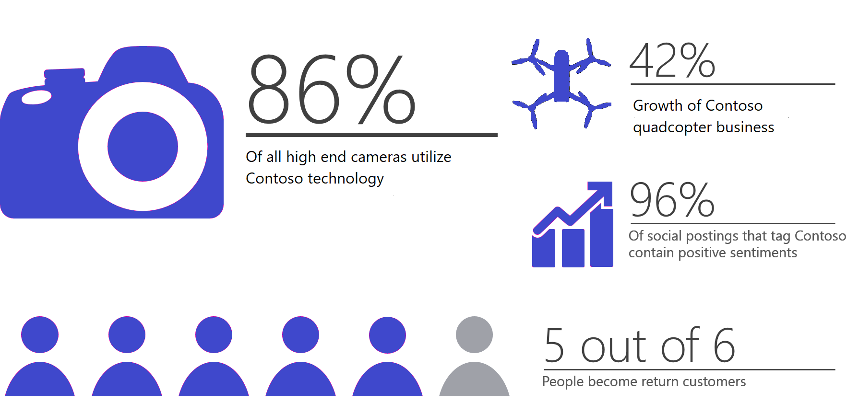

Just last quarter, Contoso experienced strong sales across all of its consumer electronics divisions, as evidenced below in Figure 3, below.

|  |  |  |  |
| --- | --- | --- | --- |
| **Category** | **Avg unit price** | **Units sold** | **Total Sales** |
| **Audio** | $146.06 | 18,415 | $1,954,835 |
| **Cameras & Camcorders** | $210.85 | 13,697 | $4,036,608 |
| **Cell Phones** | $47.66 | 38,506 | $354,286 |
| **Computers** | $173.27 | 19,323 | $2,202,471 |
| **Quadcopters** | $742.59 | 2,395 | $1,409,945 |
| **TV & Video** | $421.46 | 7,589 | $2,752,893 |
| **Contoso sales totals** | $299.84 | 99,925 | $12,711,041 |

**Figure 3:** Contoso quarterly sales, by division

## Our priorities are your priorities

Contoso is a company that stands on its priorities. That’s why partnership with Adventure Works makes sense; Contoso business priorities map directly to Adventure Works’s business goals. Our commitment to quality, consistent innovation and thought leadership, and engagement with the larger community resonate in tune with how Adventure Works does business (Figure 4).

|  |  |
| --- | --- |
| **Contoso business priority** | **Adventure Works business goals** |
| **Commitment to quality** | Deliver a solid, dependable product that customers can rely on. |
| **Consistent innovation and thought leadership** | Deliver a progressive, modern experience that customers want to keep coming back to. |
| **Community and sustainability** | Leave a positive impact on the community and environment. |

**Figure 4**: Alignment of business priorities and goals

## Customer-focused approach

Contoso has a 30-year history of excellence in the consumer electronics space, consistently giving buyers what they want: innovative, high-quality products for competitive prices from companies they know and trust. Contoso has a solid reputation; in fact, across Twitter trends from 2012-2013, the company was highly correlated with positive word associations among users who tagged *Contoso*. Worldwide sales numbers validate this approach as well—Contoso products comprised 39% of worldwide television sales last year (Figure 5).

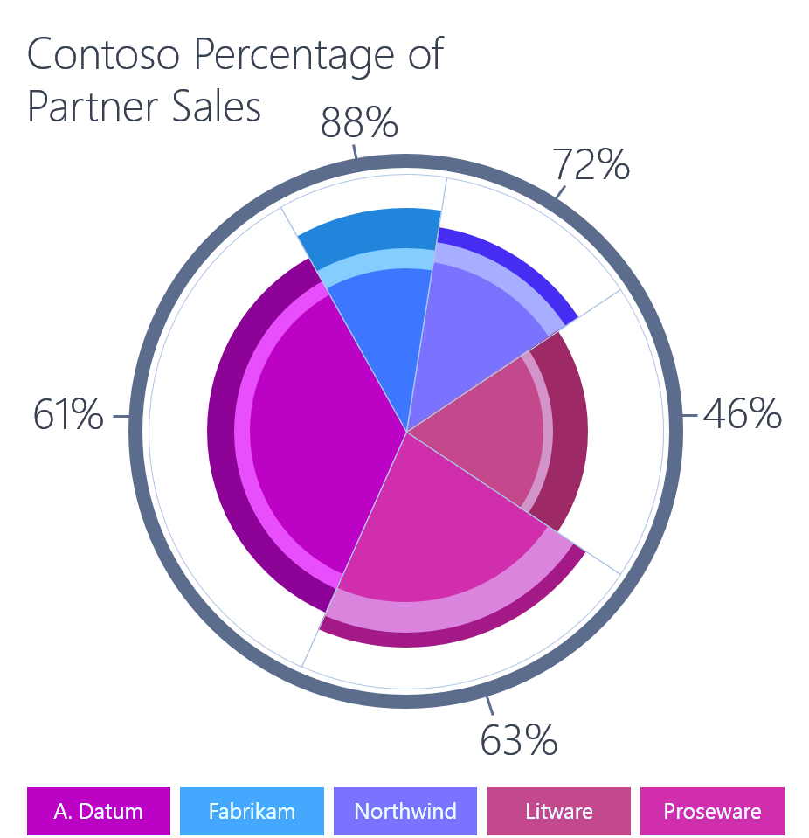

**Figure 5**: Worldwide television sales percentages for 2012-2013

At Contoso, customer satisfaction is a guiding value, and the social media feedback shows that we take this value seriously. Want a deeper level of customer engagement and satisfaction? That’s what Contoso can help provide.

# The sales alignment process

In this analysis, we have established that Adventure Works and Contoso share aligned business priorities and goals. We’ve also briefly reviewed the Contoso track record of success with past sales partner relationships. Now let’s take a look at the sales alignment process itself. When you partner with Contoso in today’s market, what can you expect?

## The approach

Here’s more good news: We have simplified our process for integrating with your business. The step-by-step partnership approach is organized in three phases: evaluate, plan, and execute & measure (Figure 5). Each is intended to build directly on the phase before it. All are designed to be straightforward and easy to enact. Please note that each phase is more thoroughly documented in the supplemental materials provided by Katie Jordan.



**Figure 6**: The three phases of the partnership process

**Evaluate:** In this phase, Contoso works with you to identify key strategic alignment areas, opportunities for collaboration, and potential new offerings.

**Plan:** Once we’ve identified the targets, Contoso representatives will organize the timelines and commitments for the proposed approach.

# **Execute & Measure:** In this phase, the plan is carried out and the potential benefits are realized.Next steps

It’s time to start working—together. Katie Jordan will contact you in the next few days to talk about next steps and the proposed approach. If you’d like to start sooner or want additional information, please contact [katiej@contoso.com](mailto:katiej@contoso.com) to learn more.